Steps to raise PR in the order below:

1. Please always get the **feature branch** latest code before you pushing own updates to Feature branch.
2. Then Sync own changes to **feature branch**
3. Once done with updates to **feature branch**, click on Team Explorer || Home Icon || Branches

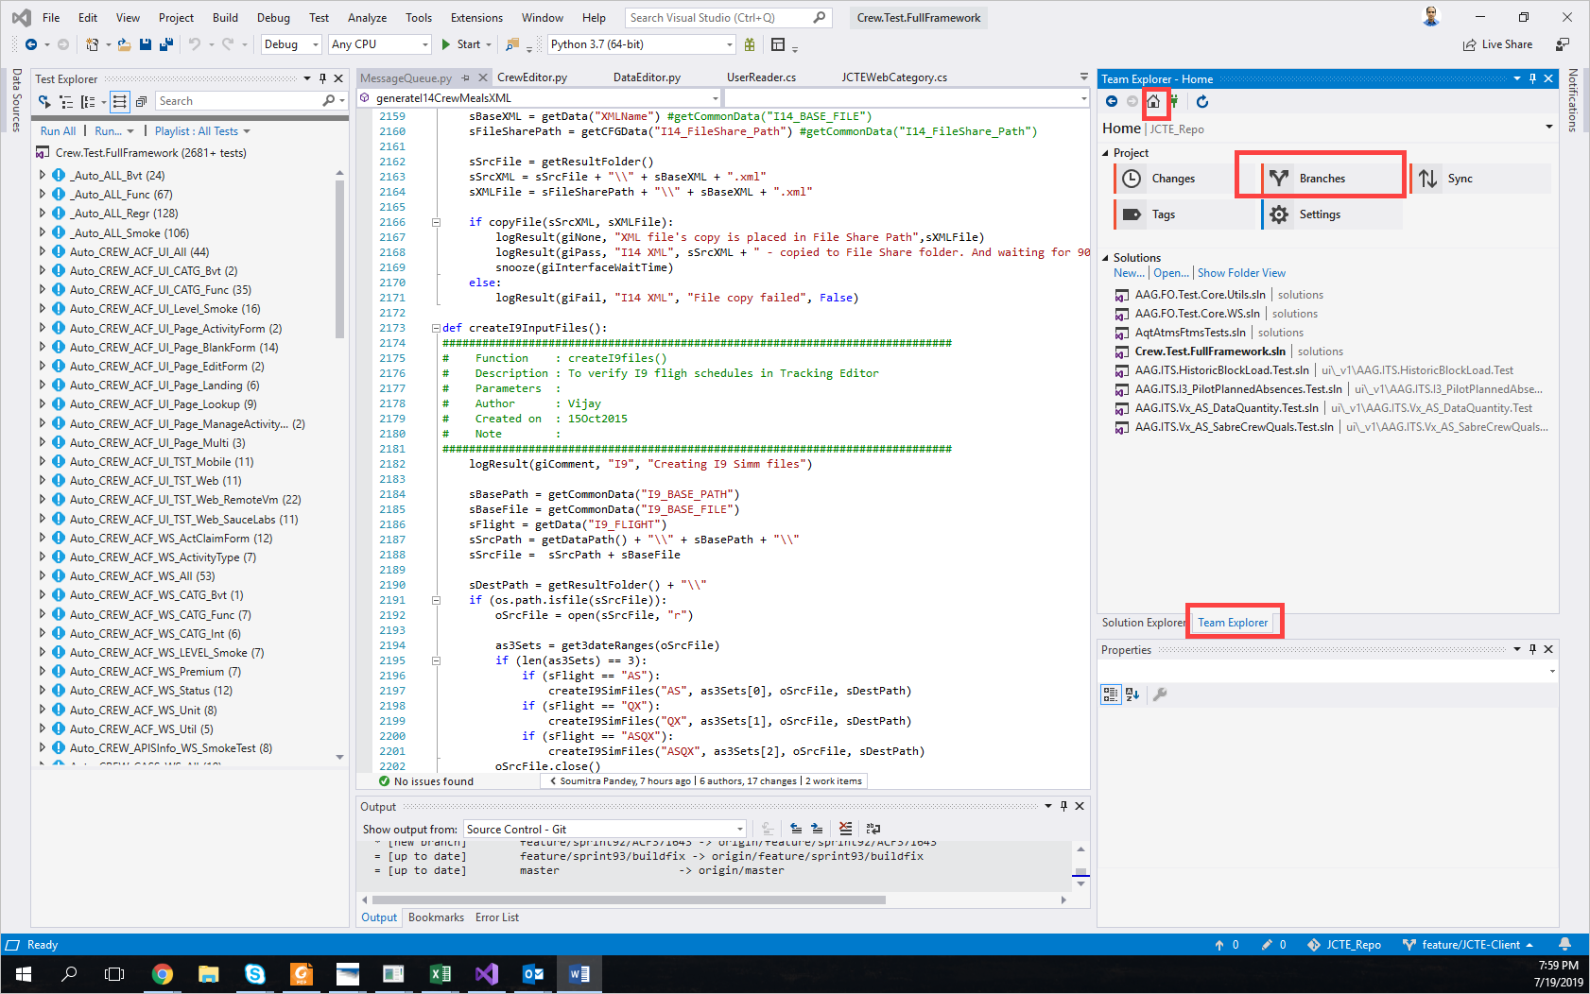

1. Click on Merge

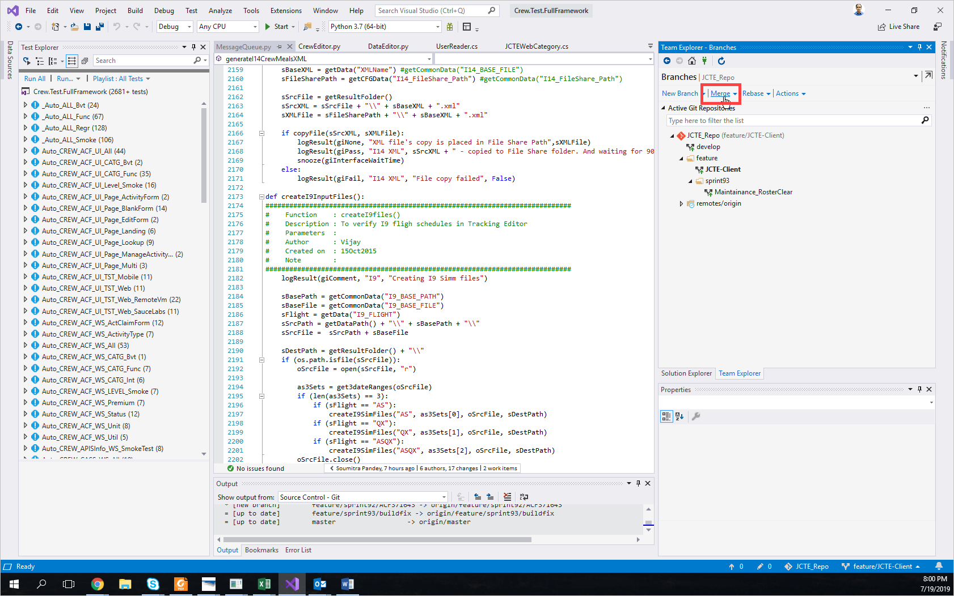

1. In the Merge from Branch: Select Develop

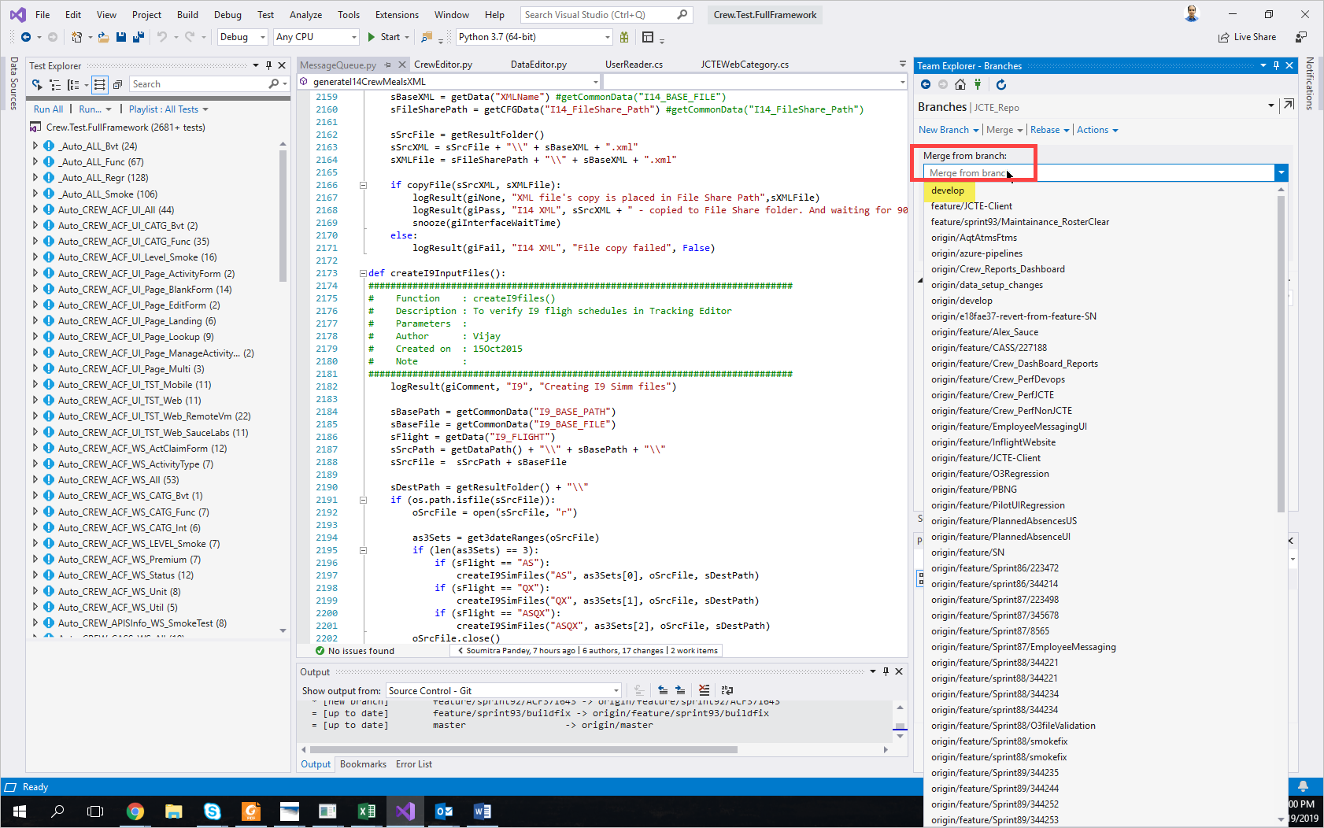

1. In the Into current branch: ensure that feature/JCTE-Client is there

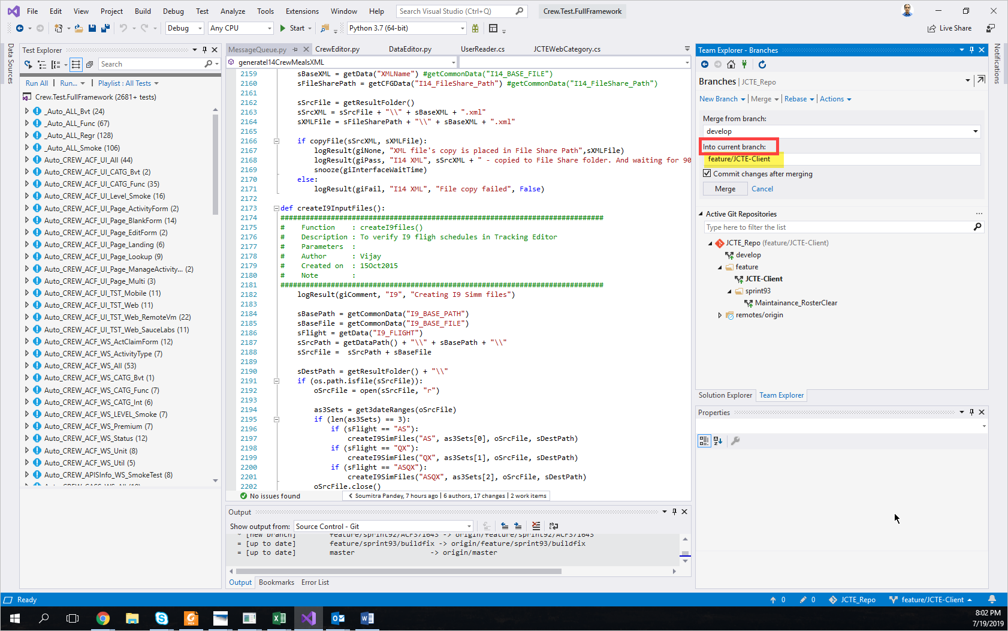

Click on Merge:

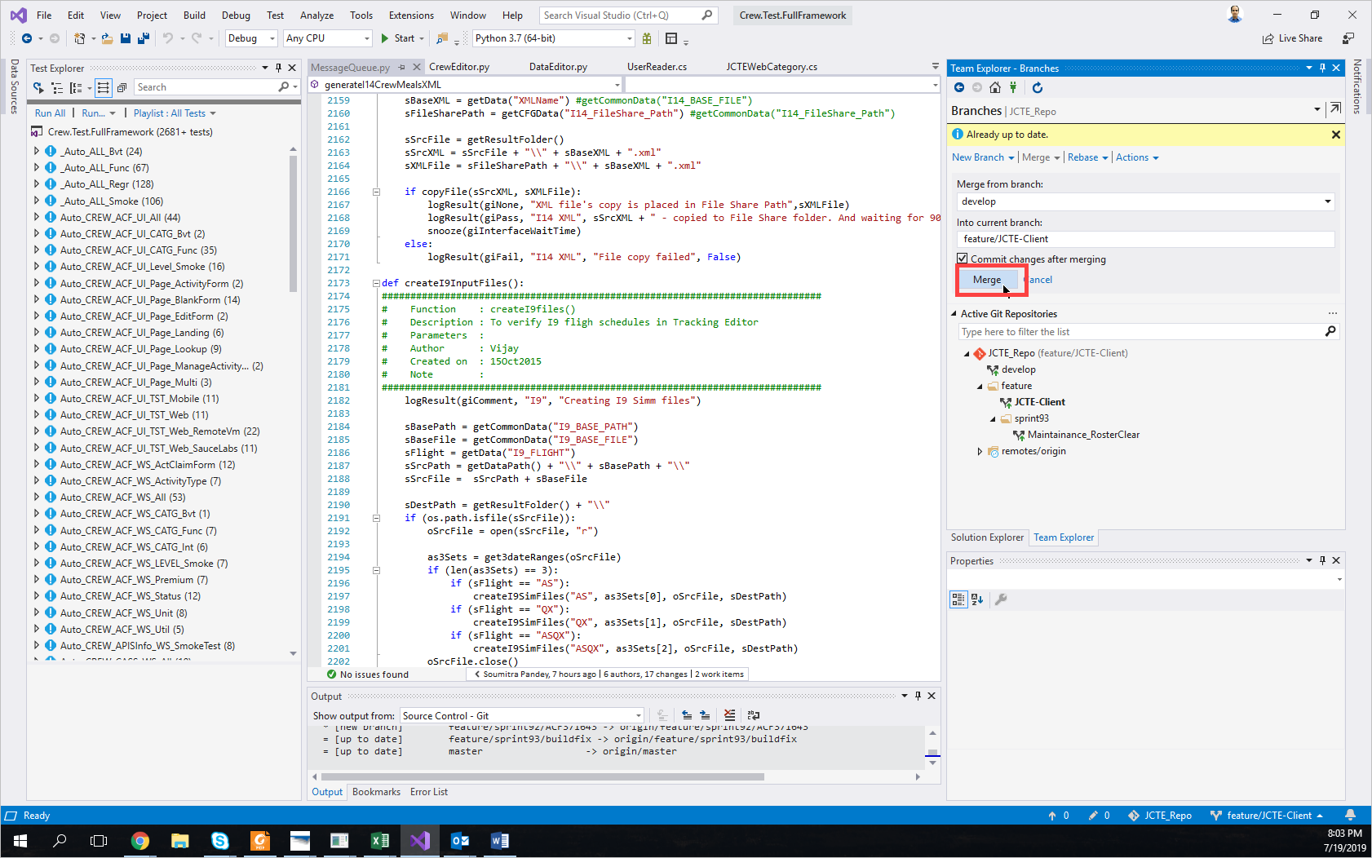

Then will see already up to date or changes will be done from develop to feature / JCTE Client branch.

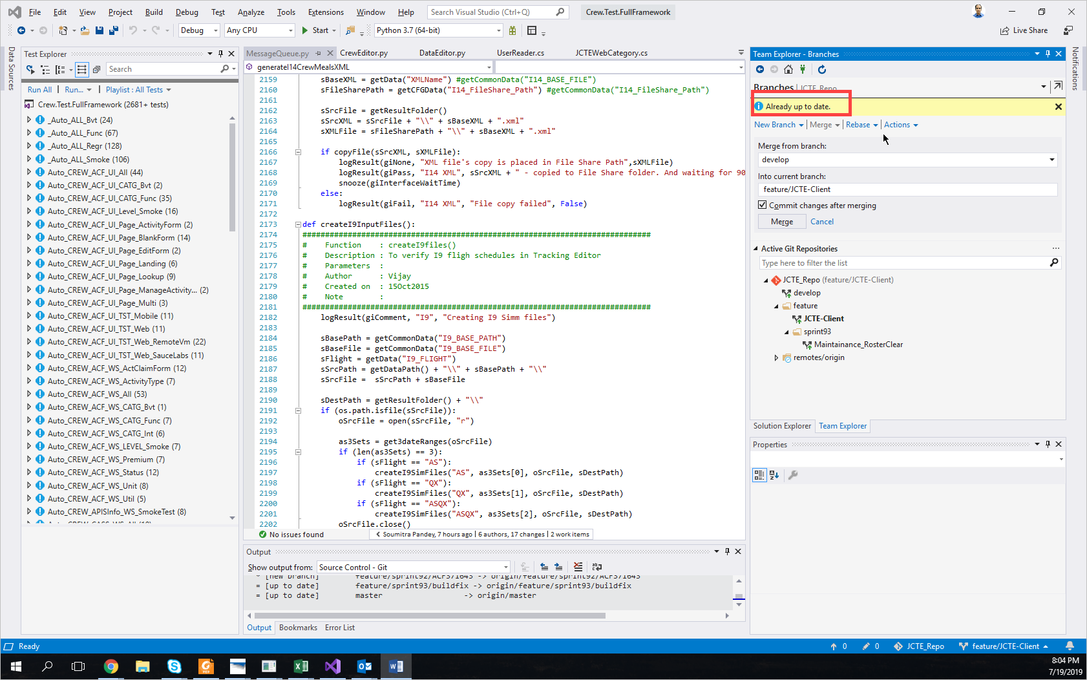

After the above is done, please go to Pull Request page:

<https://itsals.visualstudio.com/Crew/_git/TestAutomation/pullrequests?_a=mine>

Click on new pull request select a source should be feature branch into should be develop.

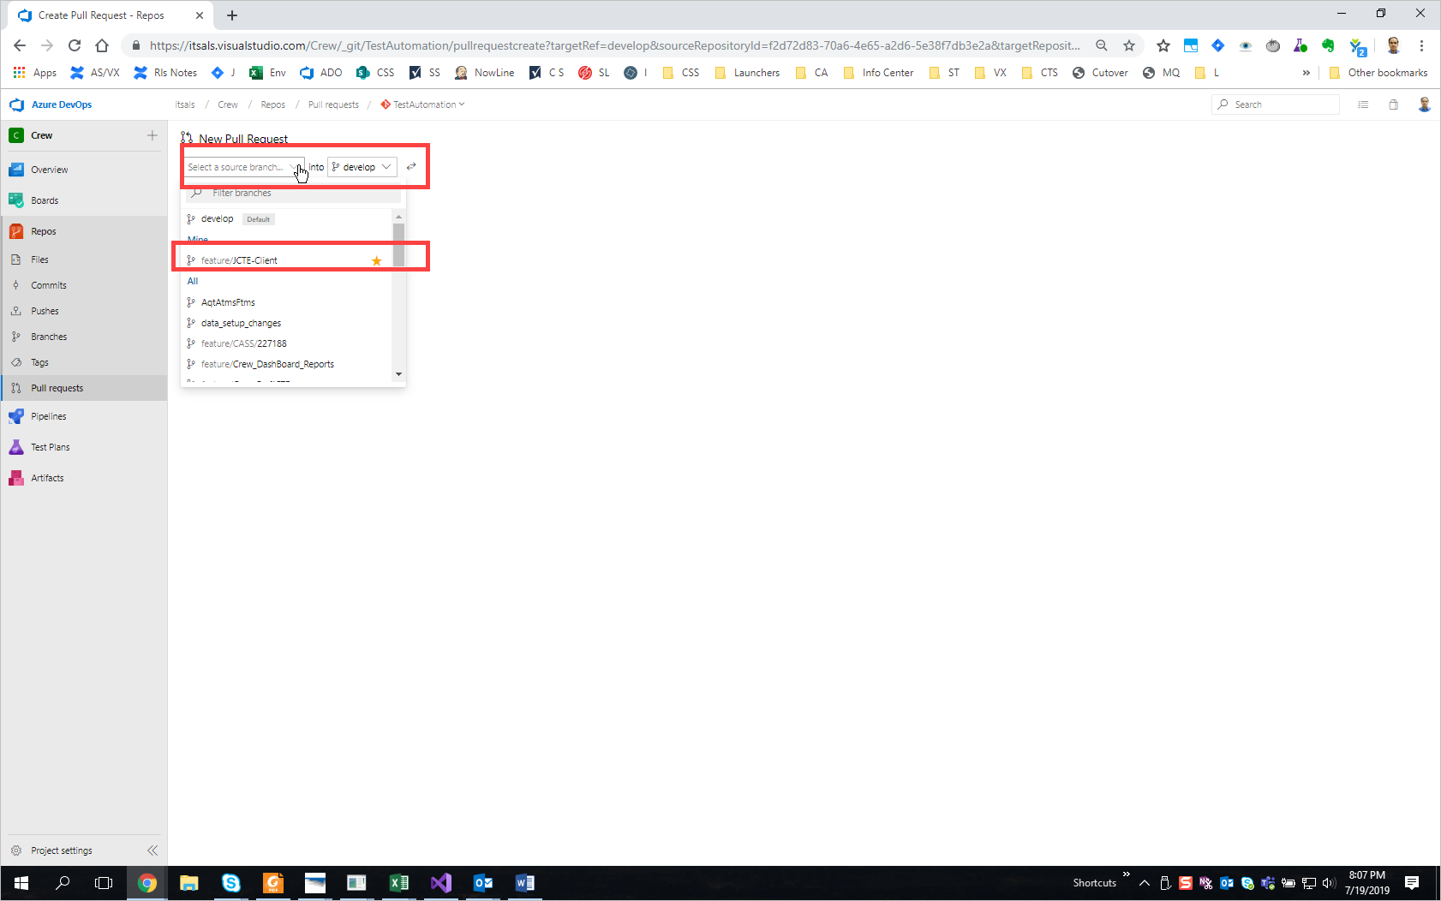

Ensure that everything is filled in.

